  - Welcome to figgjo

Are you new in figgjo?
Have you moved here from another town close by or is this your first time in Norway? Whatever your answer and the reason you are here, we would like to wish you a warm welcome you to our village.
Figgjo is home to 2213 (2016) residents many of whom were at one stage also new to the area.
This booklet is designed to give you some information about the area in general. Should you have any questions that are not addressed here please don´t hesitate to contact one of us mentioned on page 6.
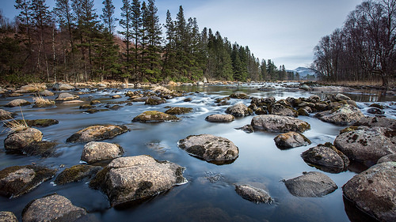

History
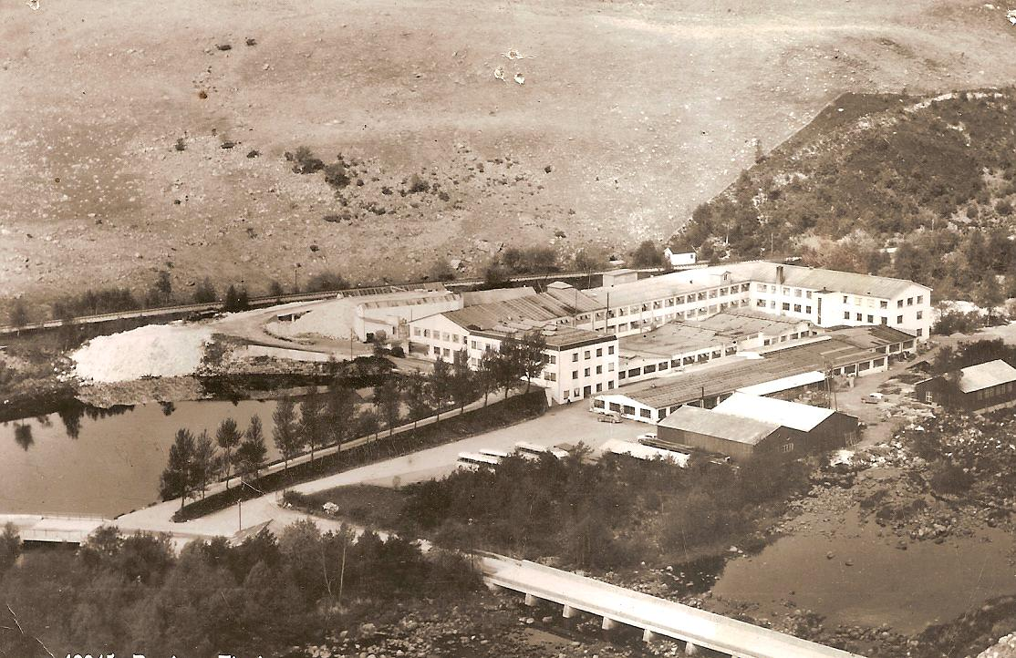
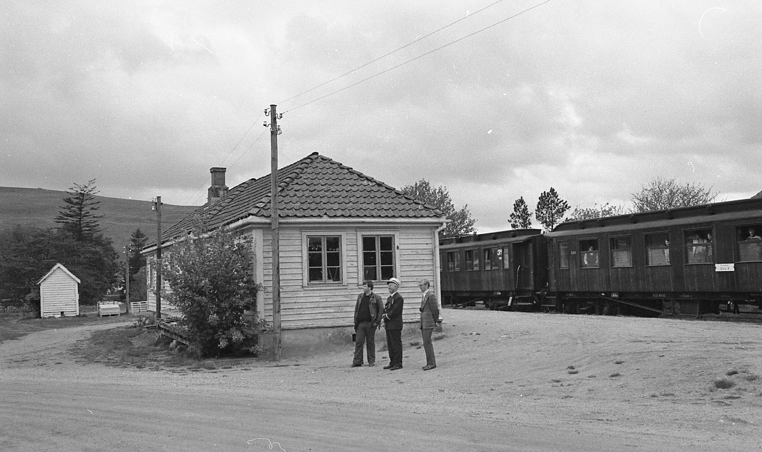
Locally, Figgjo is known as ”Figgen” and grew around the clothing factory The United Wool Manufacturers. DFU attracted workers who settled in Figgjo. This factory has now closed. Figgjo was also a railway station on the Ålgård Railway line.

Figgjo Skole (Figgjo School)
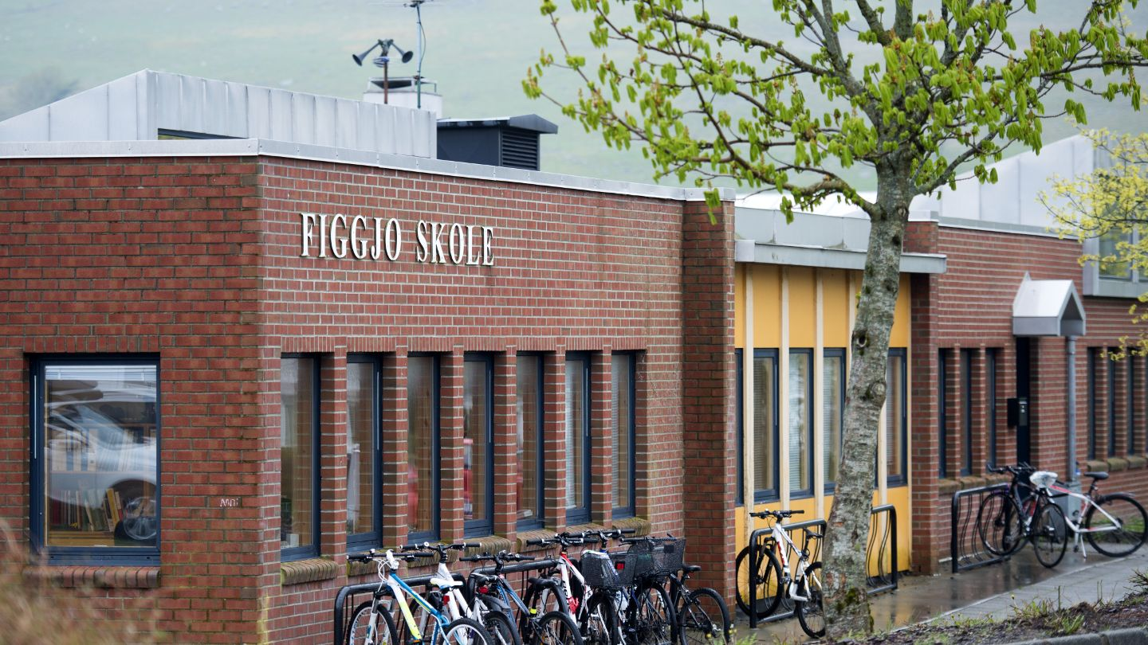
- Parent contacts (Klassekontaktene)
We plan parent/teacher meetings together with the teachers.
- We review annual plans and educational material together with the teachers for the next half-year and identify parents’ needs for information.
- We maintain good contact with the pupils and assess what the parents can do to develop a good environment within the group. Draw the pupils as much as possible into the contact between home and school.
Parent Meetings (Foreldremøter)
Ask questions!
At parent meetings, you can ask questions, such as:
- What expectations does the school have of us as parents?
- What can I expect from the school?
- What can I do to follow up the schooling at home?
- How can I contribute to a strong social community and a good learning environment?
FAU (Parents Association)
All parents who have a child at a school are members of the school’s parents’ council. The parents’ council elects a working committee (Norwegian abbreviation FAU), which represents the voice of the parents with respect to the school. The working committee is responsible for ensuring that parents have a real influence and is also jointly responsible for ensuring that the pupils’ learning environment is secure and good.
Please see attached information booklet for more detailed information.

Figgjo Barnehagen (Créche, kindergarten)
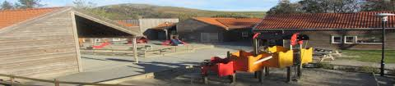
Address Utslåtten 2A
Telephone number 51 33 78 50
EngleOngane Barnehage (Creche, kindergarten)
Address Tjessheimveien 8
Telephone number 51 66 51 40

Shops in Figgjo/Ålgård
Joker
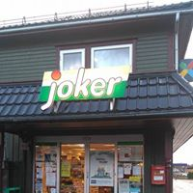
Rema 1000
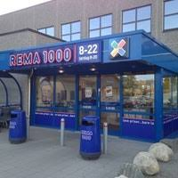
Figgjo Porcelain factory
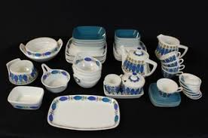
Figgjo porcelain is a leading manufacturer of porcelain in both Norway, Scandinavia and all around the world. It is used by reknowned chefs and restaurants all around the world.
Many of Figgjo´s products have won international design prizes.
Figgjo´s factory outlet is open Monday- Sunday
For more information visit www.figgjo.com
Trenja (Gym, training studio)
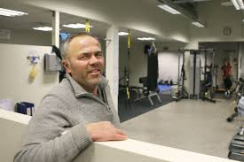
Trenja training studio is located in Figgjo Hall. They have a good choice of training equipment including weights, treadmills and a spinning room. For more information please contact the manager Jan Terje (pictured) at 900 52 427.
Figgjo Huset/ Figgjo Hall
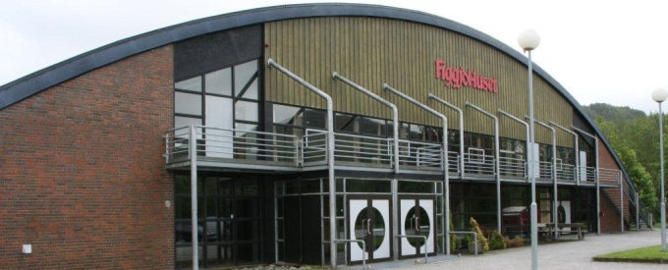
The school uses Figgjo hall for gym and other activities throughout the year, including “Figgjo kveld” which is held annually on the 1st Thursday of December. The hall also houses the gym Trenja and rooms can be rented for special events.
Contact Jan Terje at 900 52 427 for more information

Figgjo Sports Club
Figgjo IL has many activities such as football, handball, turn and ski shooting for both children and adults. Most families in the area are connected to the club in one form or another. If you wish to join or get some more information please visit their website or send a mail to trond.ove.utvaag@lyse.net
Figgjo River
Our river is very popular for sports fishing and is one of 10-15 salmon fishing rivers in Norway and the most famous in the region. The river is over 24 km long. The children of the area are permitted to fish at any time however adults need to pay a fee and obtain a license.
Sandnes Police Station
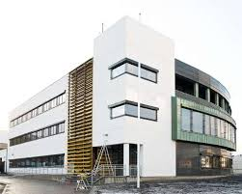
Address Gjesdalbakken 7, 4306 Sandnes
https:// whttps://www.politi.no/en/ww.politi.no/en/om/organisasjonen/politidistrikter/sor-vest/sandnes-politistasjon/

Sandnes Kommune
The entire website is available in all languages and has valuable information about social services, schooling and housing.
https://www.sandnes.kommune.no

Library and internet:
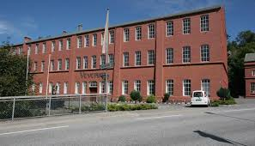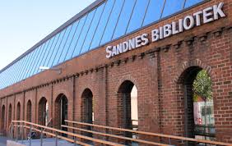
There are two public libraries close to Figgjo. One in Sandnes and another in Ålgård. If you do not have a computer at home, you can use the library´s computers free of charge during their opening hours. You also have the opportunity to borrow books, dvds and video games.
http://sandnesbibliotek.no
http://gjesdal.folkebibl.no

